**CHAPTER 1**

**INTRODUCTION**

**1.1 PROBLEM DEFINITION**

In India, access to free healthcare remains a big issue especially in the rural parts of our country where the many of the downtrodden citizens of our country live. Healthcare when available is also quite expensive and this has impacted the poor of our country the most.

Another issue that is common in our country is the lack of timely access to blood, organ and plasma banks which have resulted in many lives being lost. The COVID-19 pandemic has once again shown the importance of maintaining these banks as plasma from recovered patients has proved to be effective in treating those who have been infected.

**1.1.1 OBJECTIVES**

Once developed, the application will provide services to

* Register users and maintain a database with their required information
  + Register Blood Banks/Hospitals to record blood/organs available with them
  + Help those users who require immediate access to blood, plasma and vital organs
* Allow users to volunteer for any emergency blood donation requests.
  + Find out the nearest donor when a user has an emergency request (within a city)
  + Provide free lung cancer and pneumonia detection when given a picture using prediction models devised from machine learning algorithms.

**CHAPTER 2**

**FUNDAMENTALS OF PYTHON**

**2.1 INTRODUCTION TO PYTHON**

[Python](https://www.geeksforgeeks.org/python-programming-language/) is a commonly and extensively used general-purpose, high-level programming language. Guido van Rossum in 1991 was the founder of Python and was later developed by Python Software Foundation. It was primarily designed to emphasize on code readability, and its syntax allows programmers to express ideas in few lines of code. Python can be used for things like:

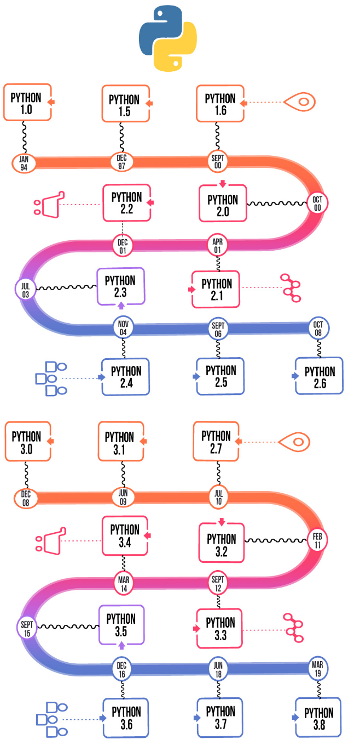

Figure 2.1: Different versions of Python over the years

**2.1.1 ENTITY-RELATIONSHIP (ER) MODEL**

The Entity-Relationship (ER) Model is an attractive high level conceptual data model. It has an entity which may be an object with a physical existence like a particular car, house, person or employee or it may be an object with a conceptual existence like an organization, a profession, or a university course. Each entity has attributes—the definite properties that characterize it. For example, a student entity may be described by the student’s name, age, address, USN etc.

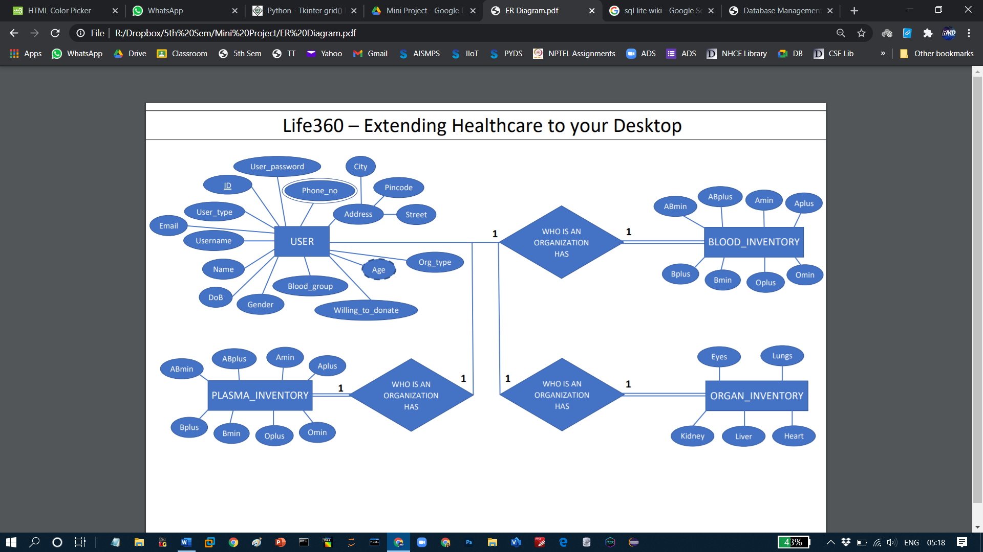

Figure 2.2: DBMS Component Modules

**2.1.1.1 ENTITY-RELATIONSHIP (ER) MODEL**

The Entity-Relationship (ER) Model is an attractive high level conceptual data model. It has an entity which may be an object with a physical existence like a particular car, house, person or employee or it may be an object with a conceptual existence like an organization, a profession, or a university course. Each entity has attributes—the definite properties that characterize it. For example, a student entity may be described by the student’s name, age, address, USN etc.

**CHAPTER 4**

**FUNDAMENTALS OF DBMS**

**4.1 DESIGN GOALS**

This mini project has ensured that the user has an interactive and explorable environment. The interface is user friendly, simple to understand and has tried to ensure that there are no bugs.

Table 4.1: Various widgets available in Tkinter

|  |  |
| --- | --- |
| WIDGETS | DESCRIPTION |
| **Label** | This widget is used to display text or image on the window/frame |
| **Button** | This widget is used to add buttons to the user interface |
| **Canvas** | This widget allows one to draw pictures and different types of layouts like texts, graphics etc. |
| **Entry** | This widget is used to take as input, a single line text entry from user |
| **Frame** | This widget is used as box or container. It holds and organizes the widgets in an orderly fashion |
| **SpinBox** | This widget allows users to select from a given number of values |
| **ComboBox** | This widget contains a down arrow to select from a list of options |
| **CheckButton** | This widget displays a number toggle buttons which represent various options from which user can select any number of options. |
| **RadioButton** | This widget is similar to the CheckButton but allows only one option to be selected |
| **Scale** | This widget is used to provide a slider which allows the user to select any value from the scale |

Various triggers were also used to ensure referential integrity and data integrity:

* Age_Calc: This trigger calculates the age from the attribute ‘date_of_birth’ when a new tuple is inserted into the table.

|  |
| --- |
| CREATE TRIGGER age_calc  AFTER INSERT ON users  FOR EACH ROW  BEGIN  UPDATE users  SET age = CAST (strftime('%Y.%m%d', 'now') - strftime('%Y.%m%d', new.dob) AS INT)  WHERE ID = new.ID AND new.usertype = "Individual";  END; |

**CHAPTER 8**

**RESULTS**

**8.1 Launch Screen**

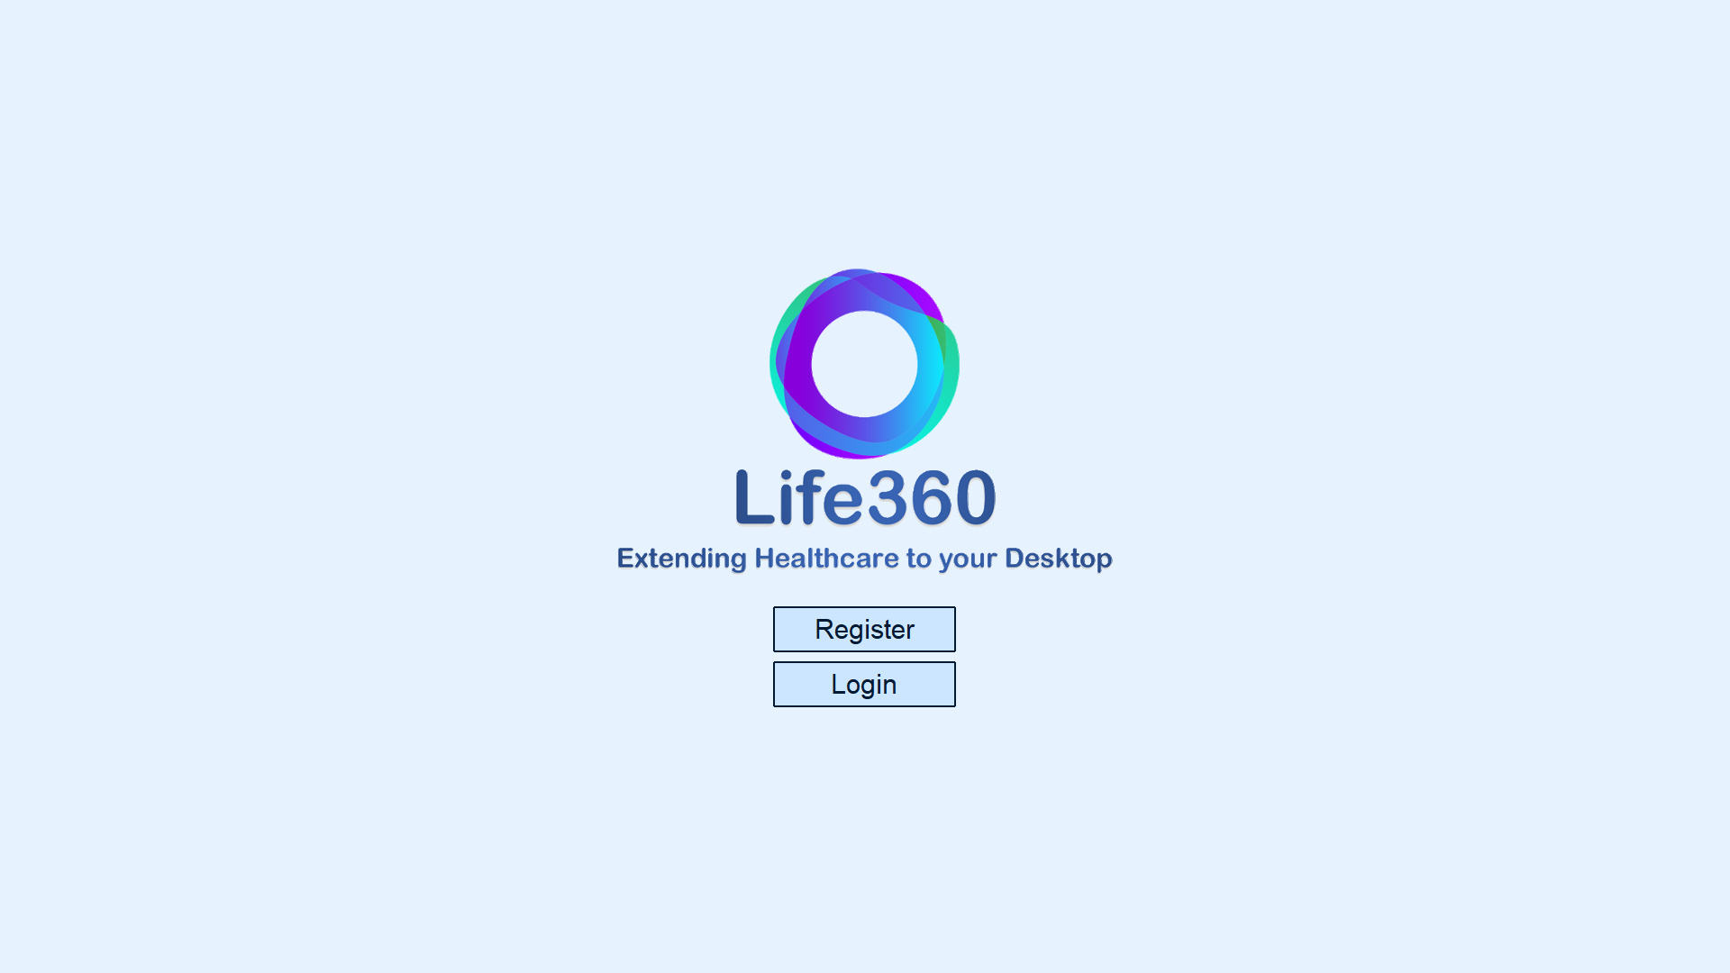

**Figure 8.1: Screen Shot of Launch Scree**

**8.1.1 REGISTERING A NEW USER (VALIDATION)**

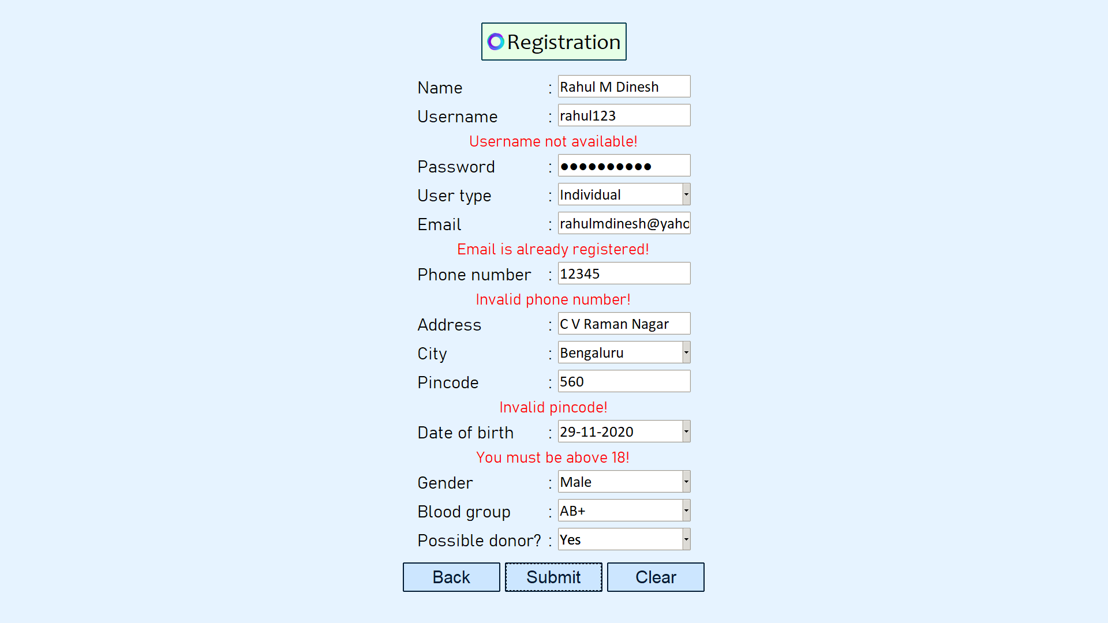

**Figure 8.1: New User Registration Screen Shot**

**CHAPTER 9**

**CONCLUSION**

The mini project has successfully accomplished the goals it had set out in the objectives and design sections of this report.

The individual user type UI has successfully implemented several modules. An individual user can opt to volunteer as a potential blood donor at the time of registration. Once logged in, the user can update his/her profile information which would be shown during a donor search by other users. The user can additionally search for near-by blood banks, organ banks, COVID-19 plasma banks and donors who have been registered on the application. The user can also upload CT scan of lungs and/or X-ray scans of chests to predict whether the scans have any abnormalities. This has been achieved by using model devised from machine learning algorithms, specifically, convolutional neural network algorithms.

**REFERENCES**

[1] <https://www.javatpoint.com/> (example for website referred)

{2] <https://docs.python.org/>

[3] A.Conci, J. E. R. de Carvalho, T. W. Rauber, A Complete System for Vehicle Plate Localization, Segmentation and Recognition in Real Life Scene, IEEE LATIN AMERICA TRANSACTIONS, VOL. 7, NO. 5, September 2009. (Example for paper referred)

[4] Joseph Yiu, The Definitive Guide to ARM Cortex-M3 and Cortex M4 Processor, 3rd Edition, Newness Publication (example for book referred)